LASER-ULTRASONIC TESTING AND DEEP-LEARNING BASED DEFECT DIAGNOSIS IN 3D-PRINTED CFRP

Hyeon-Gyu Park¹, Kyu-Jin Lee², Jung-Ryul Lee³*

^{1 2 3 *} Department of Aerospace Engineering, Korea Advanced Institute of Science and Technology, 291 Daehak-ro, Yuseong-gu, Daejeon 34141, Republic of Korea
¹ phg9603@kaist.ac.kr, ² pos2323@kaist.ac.kr, ^{3*} leejrr@kaist.ac.kr

Abstract: Since 3D-printed CFRP composites are capable of arbitrary three-dimensional shape design and have good mechanical properties, many studies have been conducted as parts materials for the aerospace industry. However, during the manufacturing of 3D printing, the offset of the nozzle may change finely or defects caused by twisting have a problem of degrading mechanical properties. In addition, there is also a problem that is subjective and takes a lot of time when evaluating internal defects. Therefore, to address these problems, we aim to develop defect diagnosis AI that can detect the location of depth-direction defects. In this study, a continuous fiber 3D printer was used to make specimens for learning data, Onyx with nylon-based carbon short fiber and carbon continuous fiber filaments were used as materials, and lamination was performed through the Material Extrusion method. And then, pulse-echo laser ultrasonic testing and a six-degree-of-freedom robotic arm are used to examine specimens. The Ultrasonic Wave Propagation Imaging (UWPI) was binarized using the visible result through X-Ray Microscope Computed Tomography (Micro-CT). The resulting data was labeled for deep learning. Convolutional Neural Network was designed to extract advanced features. The final network was optimized through hyperparameter tuning, and the reliability of diagnostic AI was verified through 5-Fold validation. Through this study, defects on specimens of continuous fiber 3D printed CFRP composites were visualized through defect diagnosis AI, and a defect detection target accuracy of 95 % for test specimens was achieved. This study is expected to give many advantages such as establishing a manufacturing process strategy by presenting the depth-direction location of the defect beyond simply determining the presence or absence of the defect.

Keywords: Aerospace industry, 3D printed CFRP composites, Ultrasonic Wave Propagation Imaging, X-ray Computed Tomography, Deep learning

- INTRODUCTION

Recently, there has been a lot of research into 3D-printed composites in aerospace. Not only does it simplify the manufacturing process, but it can reduce costs and time[1-4]. In addition, CFRP composites are replacing traditional materials in aerospace due to their lightweight performance. Despite these advantages, 3D-printed CFRP composites can acquire defects during manufacturing, which affect the structural integrity of aerospace structures [5]. The problem is that these defects are not easily detected. X-ray microscopes are often used to detect internal defects due to their high resolution, but they are not suitable for aerospace structures because they can only be used at the level of small, incised specimens [6]. Therefore, there is a need for a methodology that can be applied to aerospace structures and that quantitatively and automatedly indicates the location of internal defects. To date, many methods have been developed to utilize deep learning as a quantitative indicator of internal defects. However, most of the methods utilizing deep learning have been applied to metal specimens with simple geometries rather than CFRP composites, or even if they are applied to CFRP composites, they simply classify them as normal or defective.

To overcome these problems, non-destructive testing with Laser Ultrasonic Testing (LUT) combined with deep learning is an excellent alternative. LUT is an inspection method that is being researched to detect defects in the aerospace sector. Lee et al. visualized the location of defects using the Ultrasonic Wave Propagation Imaging (UWPI) system [7]. LUT can provide a variety of solutions that are not constrained by the environment and are more versatile than contact inspection methods such as ultrasonic testing or phased array ultrasonic testing (PAUT). In addition, pulse waves generate 1-D ultrasonic waves, and these generated bulk waves carry information about the depth-direction of the target. Therefore, this paper proposes a method to inspect 3D-printed CFRP composites with arbitrary three-dimensional shapes through LUT and quantitatively present the location and depth direction of defects through deep learning. For data collection and validation, planar shape specimen for training and curved shape specimen for validation of 3D printed CFRP composites were manufactured, and the manufactured specimens were inspected by LUT. The collected data was labeled and compared with the x-ray results, and the insufficient data was augmented with a Synthetic Minority Over-Sampling Technique (SMOTE) to form a dataset for deep learning. The dataset was trained using a Convolutional Neural Network (CNN) to simultaneously extract time series and spatial information. The final trained network was validated for accuracy through 5-fold cross-validation. This study is expected to give many advantages such as establishing a process strategy by presenting the location of the defect beyond simply determining the presence or absence of the defect.

The remainder of this paper is organized as follows. Section 2 introduces the manufacturing process and LUT method of CFRP specimens using a 3D printer. Section 3 describes the process of labeling LUT data and constructing a dataset with insufficient data augmentation, using an X-ray micro CT as references. Section 4 describes the design of a CNN and compares its performance through 5-fold cross-validation. Section 5 validates the performance of the designed deep learning method by comparing it with CT results, and visualizes the diagnostic results of the deep learning AI. Finally, Section 6 concludes the paper.

- MANUFACTURING SPECIMENS & LASER ULTRASONIC TESTING

Fabrication of composite 3D-printed specimens
Two specimens were fabricated to simulate defects that can occur during composite 3D printing and to obtain training and validation data for the deep learning model. Figure 1 shows the fabricated specimens and slicing images of the two specimens. The most common defect that occurs when continuous carbon fibers are incorporated for structural reinforcement was debonding between the continuous carbon fibers and chopped carbon fibers [5]. This defect was mainly caused by calibration errors during the long-term 3D printing process. Additionally, to simulate defects under various thickness conditions, the specimens were divided into three sections with wall thicknesses of 2.0 mm, 2.4 mm, and 2.8 mm, respectively. The internal structure of both specimens shown in Figure 1 (a) and (b) is identical, but they were fabricated in both planar and curved shapes to verify the robustness of the deep learning model with respect to curvature.

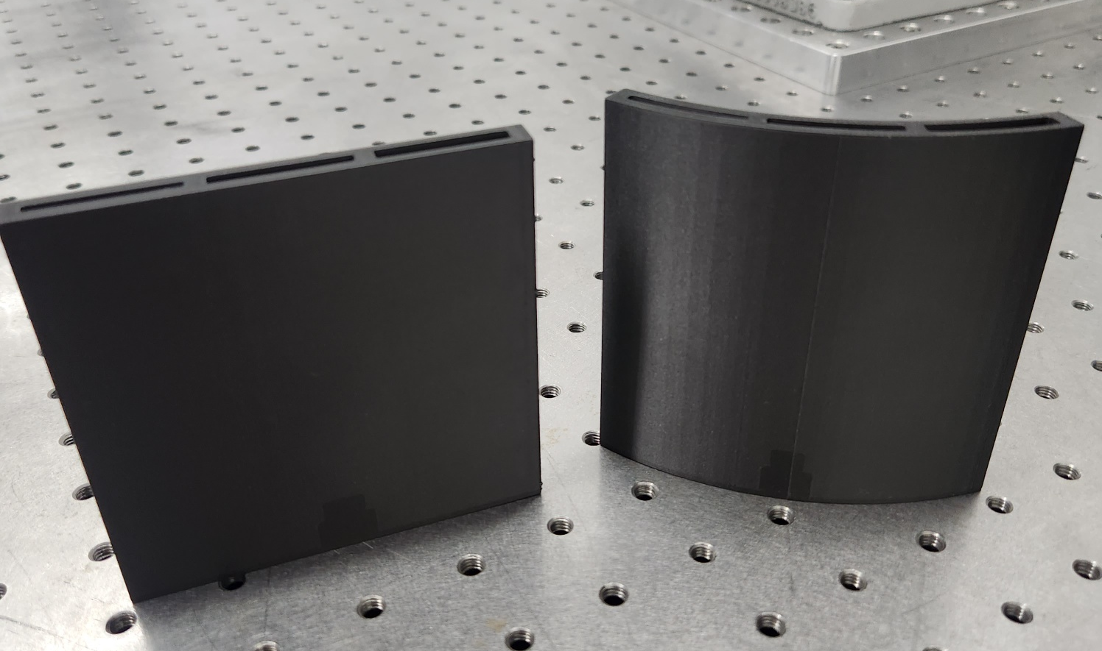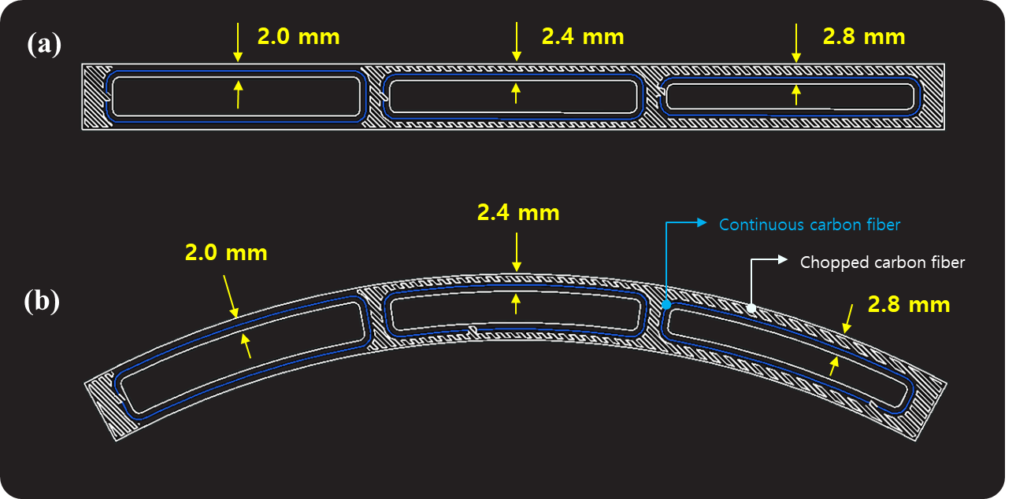
Figure 1: The fabricated two specimens and the cross-sectional information of the specimens used to acquire laser ultrasonic testing data, (a) planar shape, (b) curved shape

Robotic pulse-echo laser ultrasonic testing
The non-destructive testing method used to obtain defect data was LUT, which utilizes the principle of laser ultrasonic. Unlike conventional non-destructive testing methods, LUT is a fully non-contact method that generates ultrasonic waves using a pulsed laser and measures the ultrasonic signals using a laser Doppler vibrometer, thus eliminating the need for contact or couplant. With these advantages and the potential for automation, it can be applied to complex shapes beyond simple structures.

To acquire reliable 1D ultrasonic wave signals with thickness information for training the deep learning model, the robotic PE LUT system was employed. This system uses a 6-axis robotic arm as a manipulator, which was controlled to obtain optimal signals from the two specimens fixed to its tip. The entire area was inspected for signal acquisition.

- CONFIGURING DATASETS

For accurate data labeling of the fabricated specimens, an X-ray micro CT was used. The collected CT images were processed through Dragonfly of Object Research Study (ORS). According to Amine Cherraqi et al, robust CT images of the lungs were obtained by utilizing the Minimum Intensity Projection (MIP) technique[8]. In this paper, the 3D CT images are cropped to be identical to the laser ultrasonic scan plane, and one robust defect image is obtained for each depth using the MIP technique. Then, binarization was performed using the Otsu method. Figure 2 shows the CT image of the manufactured specimen and the images obtained by MIP. The data is then matched with the UWPI results to obtain 1-D laser ultrasonic data. Figure 3, Figure 4 show the matching process and the extracted 1-D signals. It can be seen that the signals vary due to the depth difference. The data generated from 3D printing is imbalanced, and therefore, data augmentation is necessary to prevent the overfitting of the training dataset. The Synthetic Minority Over-Sampling Technique (SMOTE) was used for data augmentation[9]. SMOTE is an oversampling technique commonly used in machine learning, which involves extracting one data point from the minority class data, computing the differences between it and the k-nearest neighbors, multiplying these differences by random numbers between 0 and 1, and subsequently adding these values to the original data. This operation generates new data points that resemble the original ones, thereby increasing the number of samples in the dataset. This technique has the advantage of preventing overfitting better than simple oversampling. After data augmentation, the entire dataset was divided into five sets to perform 5-fold cross-validation, with four sets used for training and one set for validation to evaluate the accuracy of the CNN. The final dataset is listed in Table 1.

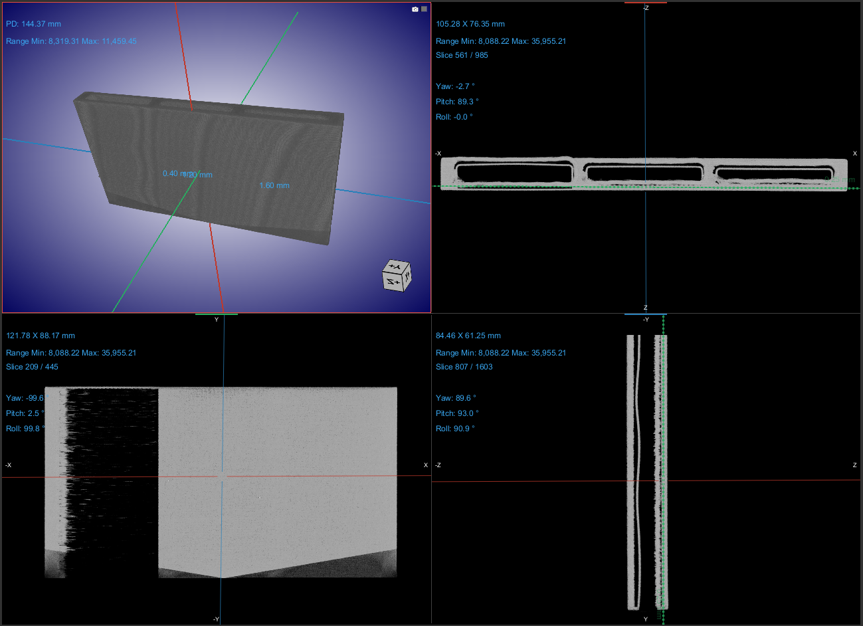
Figure 2: Micro-CT image, The MIP image of the scan plane is at the bottom left

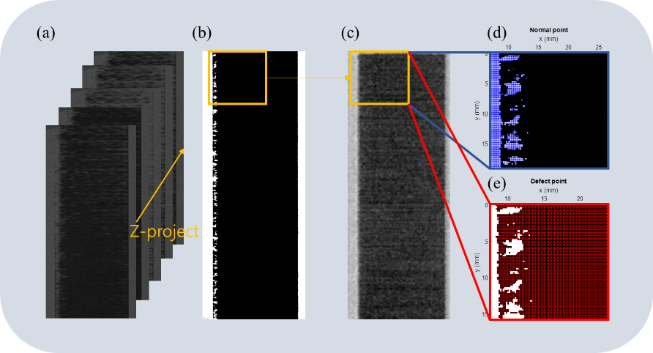
Figure 3: CT and UWPI image matching and data extraction, (a) Z-projection of each image obtained on CT. (b) Z-projected images of one robust defect image using MIP technique and Otsu technique. (c) is the signal of the same position obtained by UWPI and matched 1:1 with the image obtained by CT in (b). (d) and (e) are the extracted points of the normal region and the defect region, respectively.

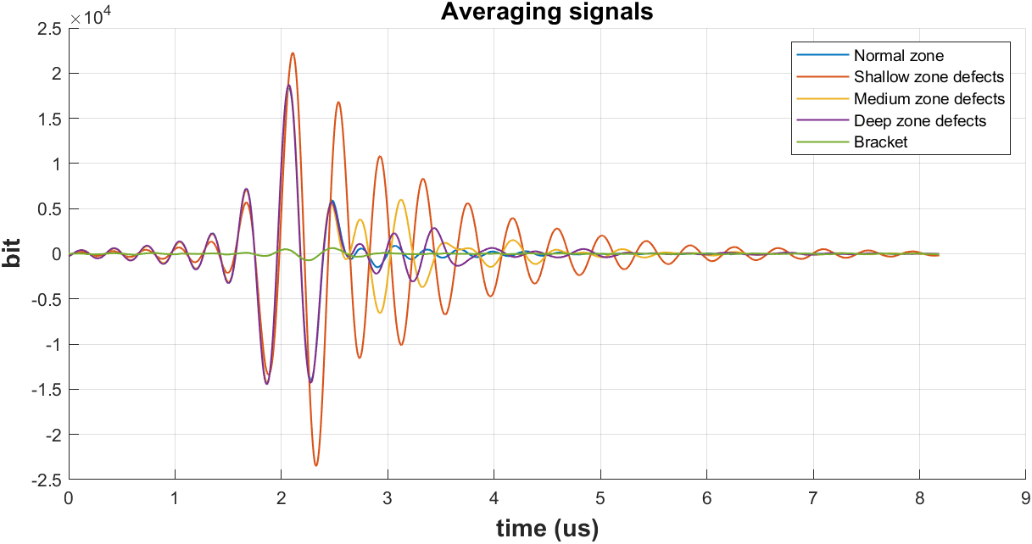
Figure 4: Extracted depth-wise averaging signals

Tabel 1. Training datasets
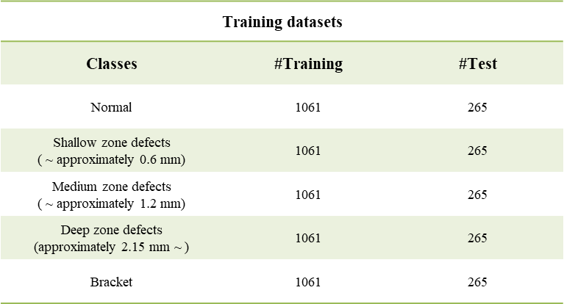

- DEEP LEARNING

Convolutional Neural Network Learning
Convolutional Neural Network (CNN) is a method of deep learning that has been used in many industries for object detection and classification since it was developed by LeCun et al[10]. CNNs use multiple arrays to store weights in a feature map and extract information. Since the data is collected through pulse-echo mode, the death of the signal is not obvious in defect, which requires the advanced feature extraction ability of the Convolutional Neural Network (CNN). In this paper, CNN is composed of 1-D CNN architectures: a 1-D CNN that uses 1-D laser ultrasonic signals as input. Features are extracted from the 1-D architecture through convolutional operations. The values from 1-D architecture are then flattened into a single layer and classified through a softmax layer. For each convolution layer, batch normalization is used to improve the performance of the gradient after convolution, and the Rectified Linear Unit (ReLU) layer is used as an activation function to prevent gradient vanishing[11,12]. The detailed architecture and hyperparameters of the CNN are listed in Figure 5, Table 2. The developed DECNN was trained using Matlab R2023b with CPU Intel i7-12700K and GPU NVIDIA GeForce RTX 4090Ti. The performance evaluation of the network evaluates the multi-classification model based on True Positive (TP), True Negative (TN), False Positive (FP), and False Negative (FN) present in the confusion matrix of the test set. To evaluate the multi-classification model, accuracy, precision, and recall are used as performance metrics, and these values are calculated. All performance metrics were calculated with k-fold cross-validation to verify the bias of the data. The formulas precision and recall are given in Eqn. 1., Eqn. 2. and Eqn. 3., respectively.

$Accuracy= \frac{TP+TN}{\left(TP+FN+FP+TN\right)}$ (1)

$Precision= \frac{TP}{\left(TP+TF\right)}$ (2)

$Recall= \frac{TP}{\left(TP+FN\right)}$ (3)

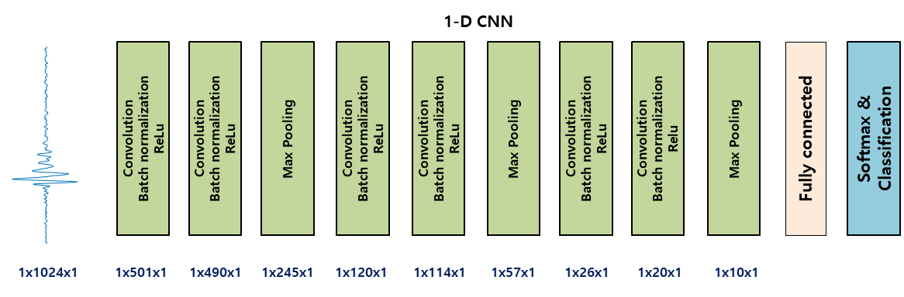
Figure 5: CNN architecture

Tabel 2. CNN Parameters
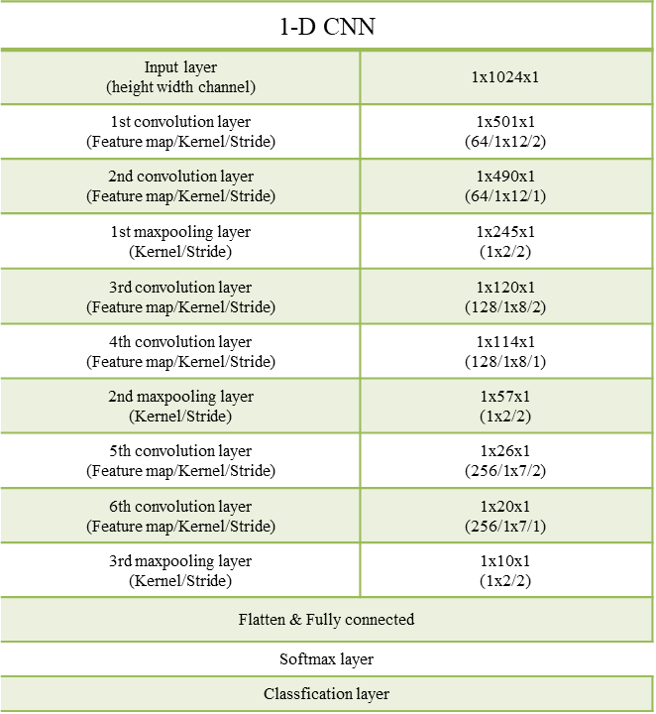

- RESULTS

CNN model performance evaluation and defect visualization
As shown in Table 1, the 5,305 data used for training were collected from the planar specimen for data collection. The sparse data, medium zone defects were augmented by 147 and deep zone defects were augmented by 262, respectively, using the SMOTE technique. The hyperparameters and training options of the designed CNN were obtained experimentally. For training options, we adopted Adam optimizer, batch size of 16, initial learning rate of 0.001, and epoch of 5. The total time required for training was 75 seconds. The CNN model performance was evaluated on 2,530 validation data collected from curved, 3D printed CFRP composites specimens that were not used for training. Table 3. shows the performance metric values calculated by 5-fold cross validation. The average of each performance metric is 95% for accuracy, 95.2% for precision and 95% for recall. This shows that each performance metric robustly achieves 95% without data bias. Figure 6 and Figure 7 show the UWPI freeze -frame results and X-ray Micro CT results of a validation curved specimen. CT is the result of viewing the curved specimen from above. The normal and defective regions in the depth-direction from the surface as seen on the CT are clearly visible over time in the UWPI freeze-frame. This provides information about the location of the defect. Figure 8 shows the predicted results of the designed CNN for each 1-D signal in the scan plane of a validation specimen collected through LUT. Similar to UWPI, it enables accurate defect evaluation by visualizing the location of defects at once and additionally indicating the depth-direction defects. The network prediction results even showed that the depth of the defect varied slightly due to the twisting of the composite, as shown in the top view of Figure 7. In other words, Deep learning-based network prediction results visualize defect areas at various depths at once and indicate their location.

Tabel 3. 5-fold cross validation result
K-Folds | Accuracy | Precision | Recall
Fold-1 | 95.3 % | 95.62 % | 95.32 %
Fold-2 | 96.4 % | 96.44 % | 96.42 %
Fold-3 | 94.5 % | 94.54 % | 94.52 %
Fold-4 | 94 % | 94.3 % | 94 %
Fold-5 | 94.8 % | 95 % | 94.76 %
Mean | 95 % | 95.2 % | 95 %

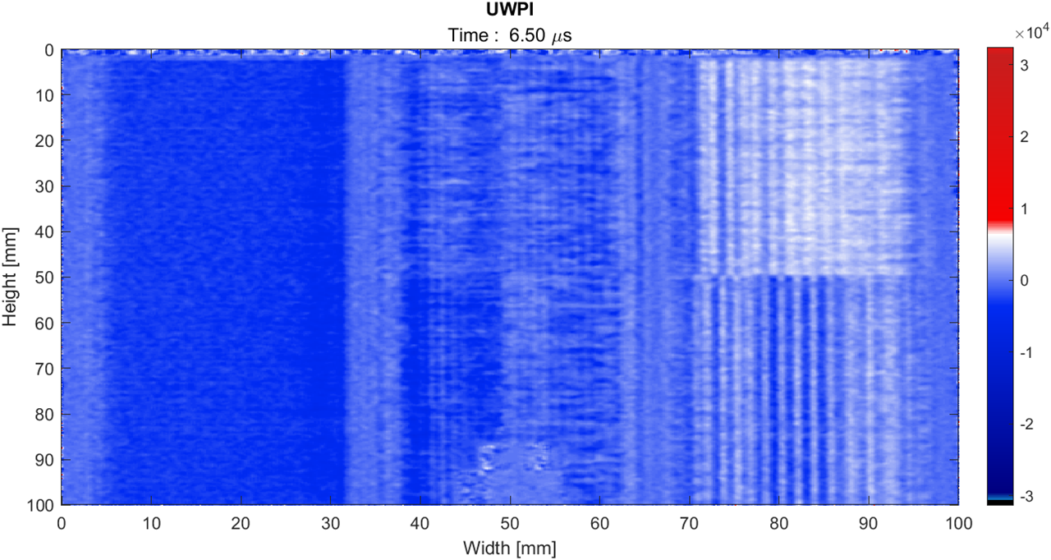
Figure 6. UWPI freeze-frame

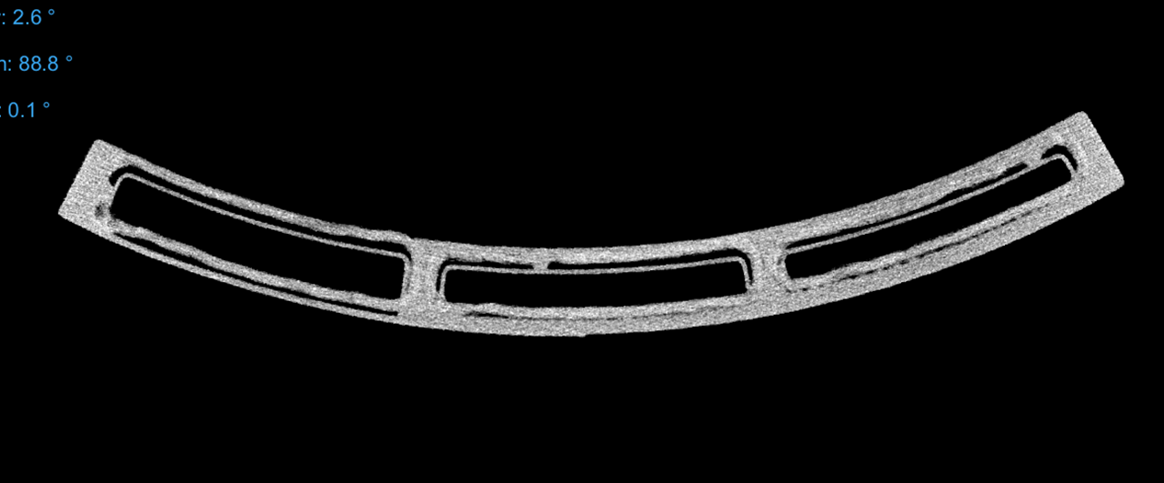
Figure 7. CT topview of the curved specimen for validation

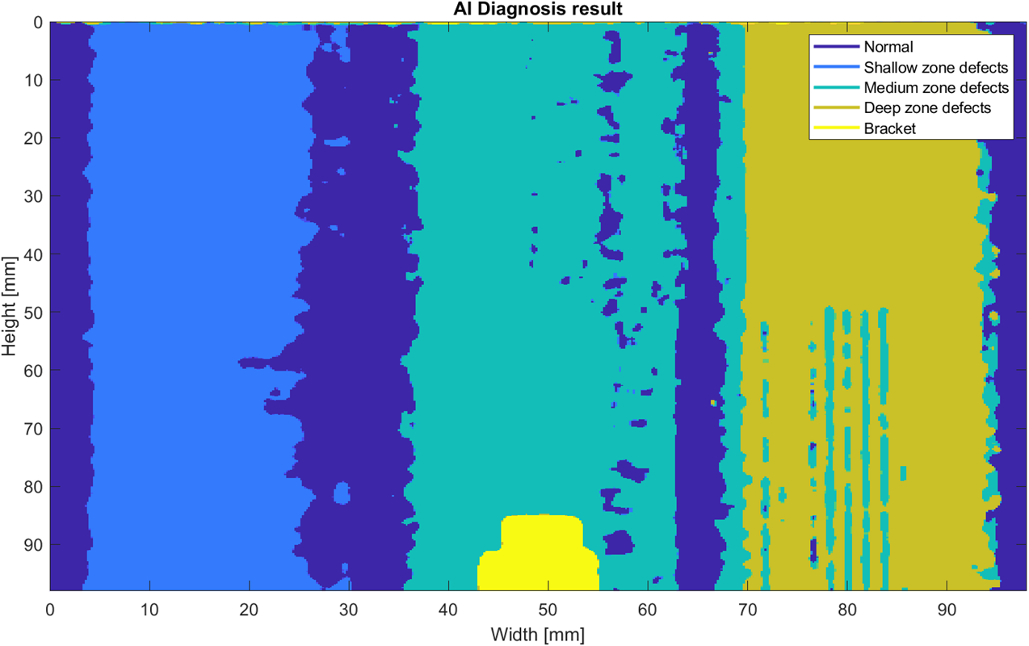
Figure 8. Diagnostic AI prediction result

- CONCLUSIONS

In summary, we verified the reliability of CNN based on deep learning for internal defects in 3D printed CFRP composites, a material that is being actively researched in the aerospace field and has high potential for application in multiple directions, and diagnosed depth-direction defects. In aerospace, the need for reliable and advanced non-destructive testing to maintain structural integrity is constantly increasing. X-ray Micro CT, a non-destructive testing method capable of acquiring high-resolution data, has sample size limitations that make it difficult to apply to real-world aerospace structures. In addition to the methodology of such non-destructive testing, accurate diagnosis of the depth-direction defects present in the structure is very important as it opens up new applications and possibilities for defect detection. To address these issues, this paper addresses the size constraint by inspecting the specimen through a LUT, and designs a CNN that sensitively extracts features from the LUT data to diagnose the location and depth-direction defects, showing a CNN performance index of 95% compared to the actual Micro-CT results. The significance of this study is that it visualizes the location and depth of defects in composites used in the aerospace field, which are not single materials, and goes beyond the simple classification of defects into normal and defective in the existing UWPI technique by providing additional depth direction information. This study can be expected to give many advantages such as establishing a manufacturing process strategy by presenting the depth-direction location of the defect beyond simply determining the presence or absence of the defect.

ACKNOWLEDGEMENT

This study was supported by the Unmanned Vehicles Core Technology Research and Development Program through the National Research Foundation of Korea (NRF) and the Unmanned Vehicle Advanced Research Center (UVARC) funded by the Ministry of Science and Information and Communication Technology (ICT), Republic of Korea (NRF-2020M3C1C1A01084220). We also performed this study based on research which has been conducted as part of the KAIST-funded Global Singularity Research Program for 2023.

REFERENCES

[1] R. Helwing, D. Hülsbusch, and F. Walther, “Deep learning method for analysis and segmentation of fatigue damage in X-ray computed tomography data for fiber-reinforced polymers,” Compos Sci Technol, vol. 230, Nov. 2022, doi: 10.1016/j.compscitech.2022.109781.
[2] P. Iassonov, T. Gebrenegus, and M. Tuller, “Segmentation of X-ray computed tomography images of porous materials: A crucial step for characterization and quantitative analysis of pore structures,” Water Resour Res, vol. 45, no. 9, Sep. 2009, doi: 10.1029/2009WR008087.
[3] Y. Gao, W. Hu, S. Xin, and L. Sun, “A review of applications of CT imaging on fiber reinforced composites,” Journal of Composite Materials, vol. 56, no. 1. SAGE Publications Ltd, pp. 133–164, Jan. 01, 2022. doi: 10.1177/00219983211050705.
[4] S. M. F. Kabir, K. Mathur, and A. F. M. Seyam, “A critical review on 3D printed continuous fiber-reinforced composites: History, mechanism, materials and properties,” Composite Structures, vol. 232. Elsevier Ltd, Jan. 15, 2020. doi: 10.1016/j.compstruct.2019.111476.
[5] K.-J. Lee, M.-S. Jeon, and J.-R. Lee, “Evaluation of manufacturing defects in 3D printed carbon fiber reinforced cylindrical composite structure based on laser ultrasonic testing,” NDT & E International, vol. 135, p. 102802, Apr. 2023, doi: 10.1016/j.ndteint.2023.102802.
[6] K. Senthilkumar et al., “Mechanical properties evaluation of sisal fibre reinforced polymer composites: A review,” Construction and Building Materials, vol. 174. Elsevier Ltd, pp. 713–729, Jun. 20, 2018. doi: 10.1016/j.conbuildmat.2018.04.143.
[7] Lee, J. R., Jeong, H., Ciang, C. C., Yoon, D. J., & Lee, S. S. (2010). Application of ultrasonic wave propagation imaging method to automatic damage visualization of nuclear power plant pipeline. Nuclear Engineering and Design, 240(10), 3513–3520. https://doi.org/10.1016/j.nucengdes.2010.06.011
[8] Cherraqi, A., El Houssni, J., Outznit, M., Imrani, K., Benelhosni, K., Billah, N. M., & Nassar, I. (2022). Incidental discovery of intercostal pulmonary hernia: A case report. Radiology Case Reports, 17(12), 4510–4514. https://doi.org/10.1016/j.radcr.2022.08.068
[9] Chawla, N. V, Bowyer, K. W., Hall, L. O., & Kegelmeyer, W. P. (2002). SMOTE: Synthetic Minority Over-sampling Technique. In Journal of Artificial Intelligence Research (Vol. 16).
[10] Lecun, Y., Bengio, Y., & Hinton, G. (2015). Deep learning. In Nature (Vol. 521, Issue 7553, pp. 436–444). Nature Publishing Group. https://doi.org/10.1038/nature14539
[11] Santurkar, S., Tsipras, D., Ilyas, A., & Mit, A. M. ˛ A. (n.d.). How Does Batch Normalization Help Optimization?
[12] Weng, T.-W., Zhang, H., Chen, H., Song, Z., Hsieh, C.-J., Boning, D., Dhillon, I. S., & Daniel, L. (2018). Towards Fast Computation of Certified Robustness for ReLU Networks. https://arxiv.org/pdf/1804.09699.

